YEARS 3/4 DOJO HOMEWORK – SUMMER HALF TERM 1
Homework activities for this term are outlined below.
You will receive ‘Dojo Points’ for each task completed and at the end of half term and they will be celebrated in class for everyone to see.
If you complete all of the tasks, you will receive a bonus 10 dojo points!
Everyone will receive a certificate for taking part.
All tasks need to be completed and returned by Wednesday 21st May.
HOMEWORK TASKS WORTH 1 DOJO POINT | HOMEWORK TASKS WORTH 3 DOJO POINTS | HOMEWORK TASKS WORTH 5 DOJO POINTS
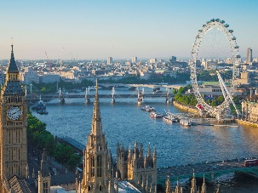  Geography: Can you name five rivers found in the UK? Are any cities located near them? | 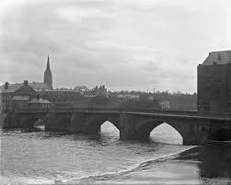  History: How has the River Dee in Chester changed over time? Has its uses change? Explore photographs and research online. | 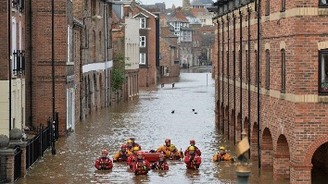  Geography: What are the effects of flooding? Create a poster warning people about the impact of flooding.
Maths problem-solving: River Crossing. Can you help the farmer cross the river? You may want an adult to help. | 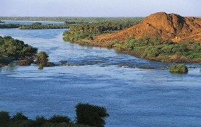  English: Create a fact file all about a river of your choice from anywhere around the world. | 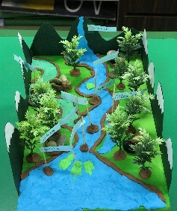  Art/DT: Create your own river artwork labelling all the different parts. You could draw it or make it 3D.

Maths problem-solving: River Crossing

Once upon a time a farmer went to market and bought a fox, a hen and a sack of corn.
The farmer came to a river which needed to be crossed by boat. He could take only one of his purchases - the fox, or the hen, or the sack of corn - in the boat at a time.

If left together on the riverbank without the farmer, the fox would eat the hen, or the hen would eat the corn.
Can you find a way for the farmer to get all of them across the river safely? (Note - only the farmer can row the boat!)

