YEARS 1 / 2 DOJO HOMEWORK – SPRING HALF TERM 2
Homework activities for this term are outlined below.
You will receive ‘Dojo Points’ for each task completed and at the end of the half term; your homework will be celebrated in class for everyone to see.
If you complete all of the tasks, you will receive a homework celebration certificate and a bonus 10 dojo points!
All tasks need to be completed and returned by Wednesday 2nd April.
HOMEWORK TASKS WORTH 1 DOJO POINT | HOMEWORK TASKS WORTH 3 DOJO POINTS | HOMEWORK TASKS WORTH 5 DOJO POINTS
Art: Create a portrait of Queen Victoria or Queen Elizabeth I.  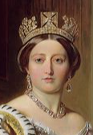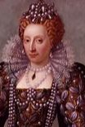 | DT: Can you design an outfit that Queen Victoria might’ve worn.  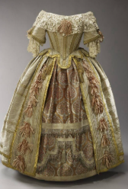 |   English: Write a postcard or short diary entry from a Victorian child who works in a workhouse, is a chimney sweep or works down a mine.
English: Find out who lived at Osbourne House and write 3 sentences to tell us.  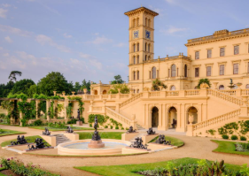 | History: Make a timeline for an elderly relative or family friend showing important events that have happened in their lives.  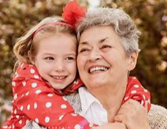 | Maths: Make a matching game to practise number bonds to 10.  

